++

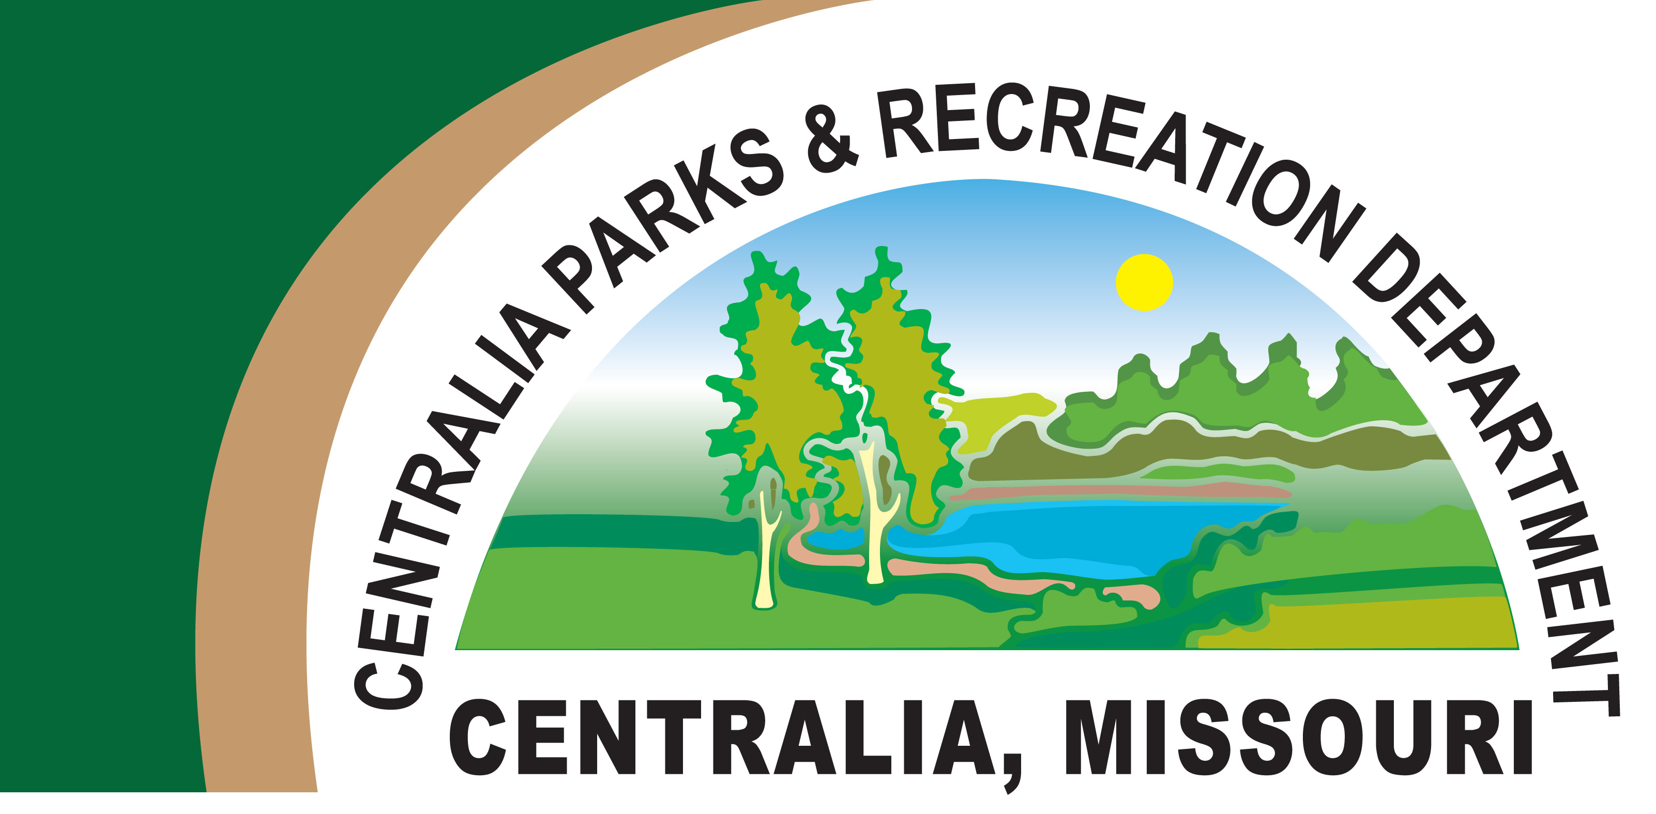

Centralia Park Board

Agenda

Tuesday, August 15, 2023

12:00 PM

Centralia Recreation Center

682-5063

1. Call to Order
2. Reading of Minutes
3. Treasurer’s Report—Not ready
4. Closed Session
5. Recreation Center Report
   1. Memberships—Current-2, 782 / Last Month- 2,776 / Last Year-2,543
   2. Classes—Senior in Shape M-F, 5:30 PM Body Bar-13 participants/ Fall classes?
   3. Kids Club—starts Aug 22, 2023—22 signed up to date
   4. East Annex
   5. Bank Draft ACH’s
6. Park Report
   1. Pumpkin Festival Saturday October 21, 2023
   2. Wine Walk October 7, 2023—Hot Air Balloon
7. Pool Report
   1. Last Day of Attendance 7, 754 August 5, 2023
   2. Water Drain
8. Golf Course Report
   1. Rental Costs
9. Items Which May Arise
10. Adjournment

\*NOTICE OF CLOSED MEETING AND VOTE

This notice is being given more than twenty-four (24) hours prior to the meeting.

A copy hereof shall be posted at the Centralia Recreation Center. At a meeting of the City of Centralia Park Board, to be held Tuesday, August 15, 2023 beginning at 12:00 o’clock, P.M., at the Centralia Recreation Center in Centralia, Missouri, the Park Board may elect to go into closed session and hold a closed vote, and the purposes of such closed session and closed vote shall be hiring, firing, disciplining or promotion of particular employees by a public governmental body when personal information about the employee is discussed or recorded; or for leasing, purchase or sale of real estate by a public governmental body where public knowledge of the transaction might adversely affect the legal consideration therefore, provided for under Section 610.021 (2) of the Revised Statutes of Missouri.