++

Centralia Park Board

Agenda

Tuesday, July 18, 2023

12:00 PM

Centralia Recreation Center

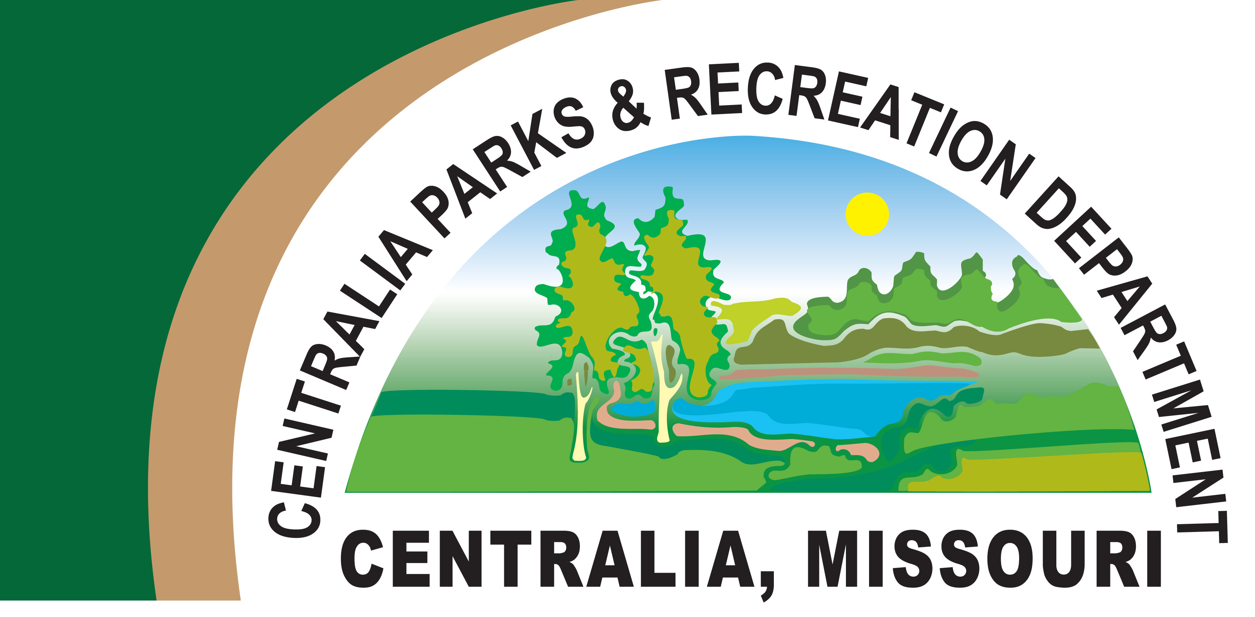

682-5063

1. Call to Order
2. Reading of Minutes
3. Treasurer’s Report
4. Closed Session
5. Park Report
6. Pool Report
7. Golf Course Report
8. Items Which May Arise
9. Adjournment

\*NOTICE OF CLOSED MEETING AND VOTE

This notice is being given more than twenty-four (24) hours prior to the meeting.

A copy hereof shall be posted at the Centralia Recreation Center. At a meeting of the City of Centralia Park Board, to be held Tuesday, July 18, 2023 beginning at 12:00 o’clock, P.M., at the Centralia Recreation Center in Centralia, Missouri, the Park Board may elect to go into closed session and hold a closed vote, and the purposes of such closed session and closed vote shall be hiring, firing, disciplining or promotion of particular employees by a public governmental body when personal information about the employee is discussed or recorded; or for leasing, purchase or sale of real estate by a public governmental body where public knowledge of the transaction might adversely affect the legal consideration therefore, provided for under Section 610.021 (2) of the Revised Statutes of Missouri.