City Of Centralia
114 South Rollins Street
Centralia, MO 65240
https://www.centraliamo.org/
573-682-2139

The City of Centralia will be conducting a lead service line inventory due to new EPA/Mo DNR regulations. In performing the lead service line inventory, we need to know the material of both the City side and the customer owned side of the service line. We are requesting your help with this identification process. Service lines can be made of many different materials such as plastic, copper, HDPE, PEX, galvanized and lead. To complete our inventory, we must record the material composition of your service line and report to the Missouri Department of Natural Resources along with the material of our service line.
The age of your home will indicate if a lead service line is present. The lead ban in Missouri was effective January 1, 1989. The ban prohibited the use of lead in potable water.
If you had a service line installed or replaced and remember when and what it was made of, you can let us know.
If you don’t know the material composition of your service line, you can perform a visual inspection where it enters your home. We have provided pictures of what these materials look like, or you can go to the Mo DNR website at dnr.mo.gov/water/business-industry-other-entities/technical-assistance-guidance/lead-service-lines.
If you are renting, you can ask the owner/manager what the service line material is. They can use the same techniques as listed above.
As we conduct the lead service line inventory, we will use the information you provide as the customer owned portion of the inventory. We will use our records for meter installation and repairs to help conduct our portion of the inventory, we will also be doing visual inspections in meter pits to check material composition as well as hydrovac examinations of the service lines.
Please contact us to report your service line material by using the attached form.
The lead service line inventory is a huge undertaking for our water system and your help is greatly appreciated.

LEAD AND COPPER RULE SURVEY

[ ] Lead (Blue Grey Color) [ ] Copper (Bronze/Green Color)
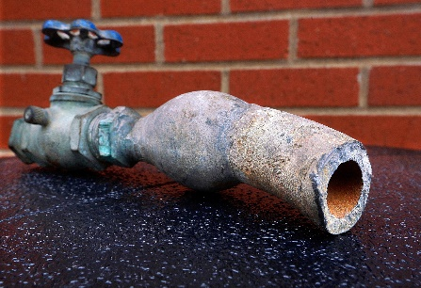

[ ] Pex (Red or Blue Tubing) [ ] PVC (White Plastic)
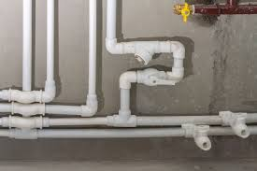

[ ] HDPE (Black or Blue Hard Plastic Tubing) [ ] Galvanized (Dull Silver/Grey)

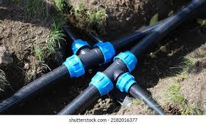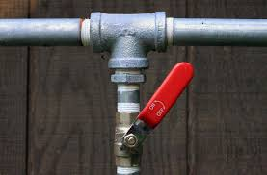

Name:

Phone Number:

Email:

Property Address:

Account Number:

Type of Occupancy (Circle one): Rent: Own:

Water service line material: (Circle one please)
Unknown Lead
Copper Plastic
Galvanized Other

Water service line installation date: (if unknown please put the year the home was built)
/ /

Source of information: (Circle one please)
Visual Inspection Lead test kit
Plumbing records Scratch test
Other

